NFREC Extension Report No: 2005-8 October 2005

Recommended Management Strategies for Bacterial Wilt on Tomato Caused by Ralstonia solanacearum

Tim Momol, Pingsheng Ji, Jeff Jones*, and Steve Olson, University of Florida, IFAS, Quincy and *Gainesville, FL

Bacterial wilt is a serious disease of tomato and many economically important crops. It is incited by Ralstonia solanacearum (Rs) and widely distributed, and causes crop losses especially in tropical and subtropical, and some warm temperate regions of the world. In the U.S., bacterial wilt is mostly seen in the Southern region. Management information provided in this section is applicable to race 1 of Rs. Symptoms of the disease (Figs. 1 and 2) and signs of the pathogen ( Fig. 3) could be used for field diagnosis of this disease.

Preplant
• Choose resistant or moderately resistant cultivars (i.e., FL7514), or graft susceptible cultivar onto resistant rootstock.
• Consider a preplant soil amendment or fumigation for infested fields against Rs and nematodes [i.e. Thymol (not commercially available yet) and Telone mixture].
• Consider an effective weed control in and around tomato fields and aquatic weed control around irrigation ponds.
• Apply 3-4 years rotation and cover crops for infested fields to reduce Rs, weeds and nematodes.
• Do not irrigate rotation and cover crops with Rs contaminated pond or surface water, avoid reinfestation.
• Use well drained and leveled fields and do not use low-lying areas of the field.
• Raise soil pH to 7.5-7.6 and increase available calcium (liming).
• Consider using infested fields ( after 3-4 years rotation) during cooler months for tomato production (i.e., spring season for north Florida).

Production
• Exclude the pathogen by applying strict sanitation practices (pathogen free irrigation water, transplants, stakes, machinery, etc.).
• Chlorinate your irrigation water continuously if you are using surface water or Rs infested pond water.
• Continue an effective weed control in and around tomato fields and irrigation ponds.
• Irrigate based on water need, avoid over irrigation.
• Apply Actigard (Syngenta) if you are using moderately resistant cultivars (i.e., FL 7514). Actigard enhances resistance against this disease if it is used in combination with moderately resistant cultivars.

After harvest
• Plow under crop residue immediately.
• Start with suitable rotation and cover crops (i.e., rye for winter, sudan-sorghum for summer in north Florida) to avoid weeds that support Rs populations.

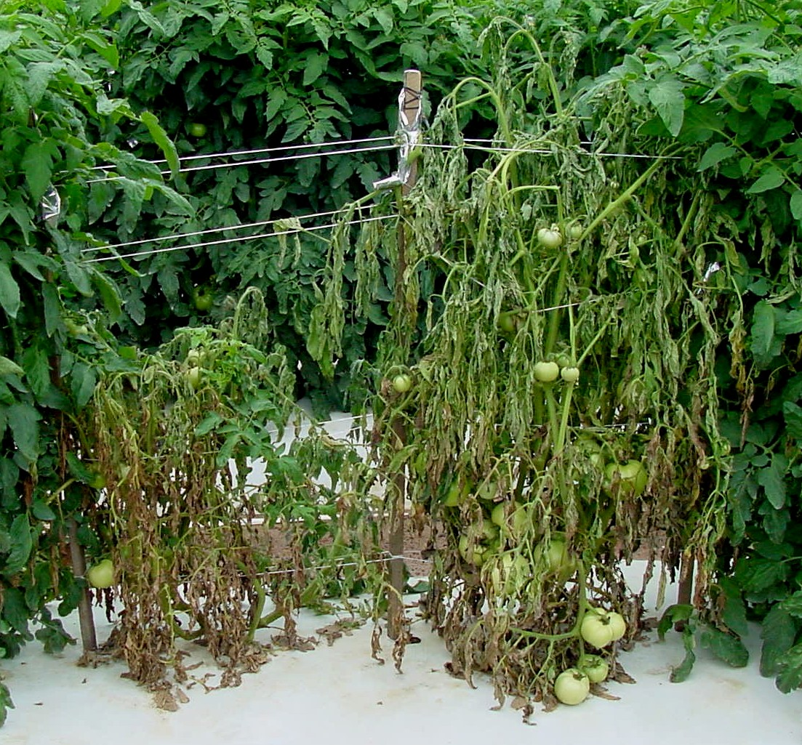

Fig. 1. Wilted green and necrotic leaves are typical symptoms of bacterial wilt on tomatoes.

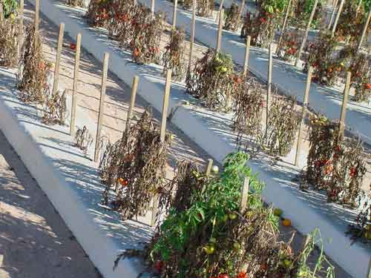
Fig. 2. Wilted and dead tomato plants in the field due to bacterial wilt.

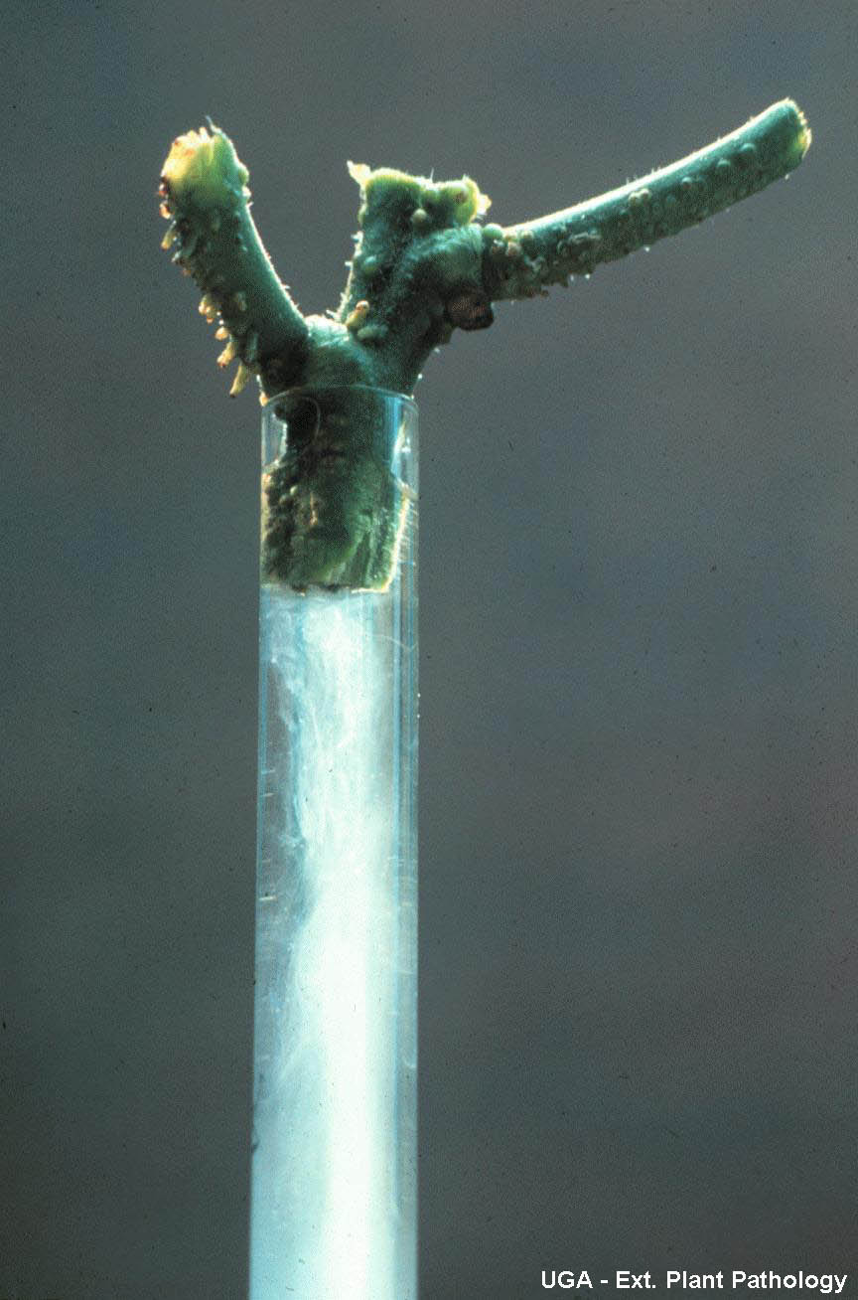
Fig. 3. White, milky ooze of bacterial cells in clear water produced by wilted plant.
(Photo Credit: University of Georgia, Plant Pathology Extension)

